Civil war in Sierra Leone

UNSC Resolution: | 1181
Date of adoption: | 13 July 1998
Operative paragraph: | 1
Demand number: | 2

Megan MacKenzie

Wording of demand

lay down their arms immediately

List of addressees of the demand
Armed Forces Revolutionary Council, Revolutionary United Front

Short-term compliance

Description of the addressee(s)’ conduct

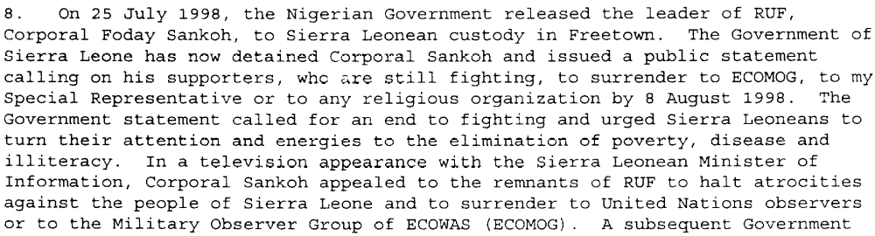

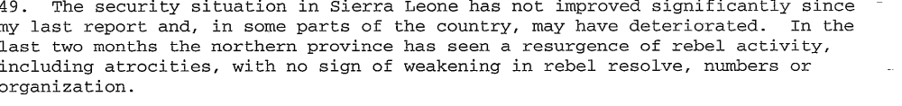
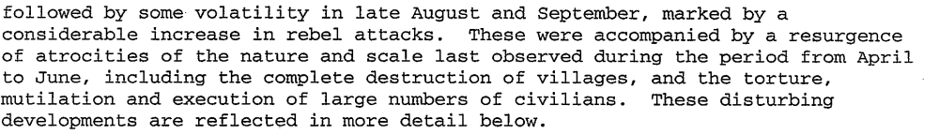

Assessment

Short-term compliance
x No or marginal compliance (1) | Medium low compliance (2) | Medium high compliance (3) | Full or almost full compliance (4)

Considerations underlying the assessment
Foday Sankoh made a request to his troops to stop fighting and to surrender to ECONOG, yet most research indicates that the RUF and AFRC continued to invoke violence and commit human rights atrocities.

Medium-term compliance

Description of the addressee(s)’ conduct
January 1998
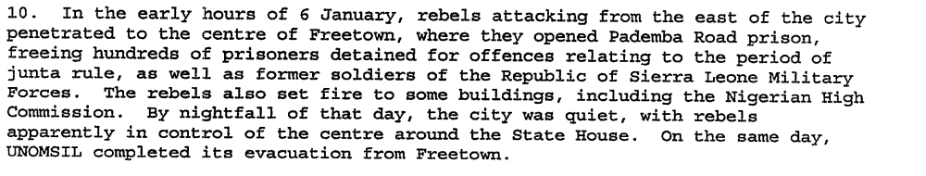
Operation No Living Thing largely directed by RUF soldiers on January 6, 1999
According to Lansana Gberie “civilians were gunned down within their houses, rounded up and massacred on the streets, thrown from the upper floors of buildings, used as human shields, and burnt alive in cars and houses. They had their limbs hacked off with machetes, eyes gouged out with knives, hands smashed with hammers, and bodies burned with boiling water. Women and girls were systematically sexually abused, and children and young people abducted by the hundreds. (2005)

Assessment

Medium-term compliance
x No or marginal compliance (1) | Medium low compliance (2) | Medium high compliance (3) | Full or almost full compliance (4)

Considerations underlying the assessment
This is clearly one of the most violent periods in the country’s history. The parties did not lay down their arms; rather, they organized the most brutal massacre of Freetown’s history.

Depth of demand

Assessment

Level of depth of demand
Low depth of demand (1) | Medium depth of demand (2) | x High depth of demand (3)

Considerations underlying the assessment
At this stage the AFRC and RUF had attained most of their power and influence through violence; therefore, ceasing violence meant a marked change in their behavior and tactics.

Level of confidence about coding decisions

Level of confidence about coding decision
x Extremely high | High | Moderate

Comments to IPI (if any)

Civil war in Sierra Leone

UNSC Resolution: | 1181
Date of adoption: | 13 July 1998
Operative paragraph: | 2
Demand number: | 2

Megan MacKenzie

Wording of demand

promote national reconciliation in Sierra Leone, work together towards this objective

List of addressees of the demand

Government of Sierra Leone, Armed Forces Revolutionary Council, Civil Defence Forces , Revolutionary United Front

Short-term compliance

Description of the addressee(s)’ conduct

In July 1998, the ministry [Ministry of National Reconstruction, Resettlement, and Rehabilitation] was replaced by the National Committee for Disarmament, Demobilization, and Reintegration (NCDDR)…The NCDDR prepared an overall strategy for DDR…the committee’s goal was to disarm some 32,000 combatants between July 1998 and January 2000, including element s from the SLA, the AFRC, the RUF, the CDF, and child soldiers.

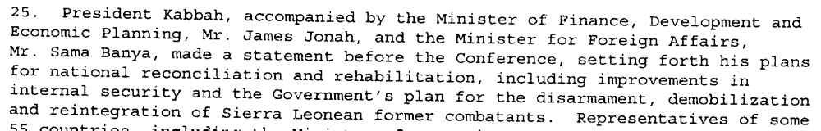

Assessment

Short-term compliance
x No or marginal compliance (1) | Medium low compliance (2) | Medium high compliance (3) | Full or almost full compliance (4)

Considerations underlying the assessment

During this period the Government of Sierra Leone made an effort to promote national reconciliation in the country. The demand, however, asks for the parties to work together towards this objective and the remaining parties clearly behaved in ways that created further insecurity rather than reconciliation.

Medium-term compliance

Description of the addressee(s)’ conduct

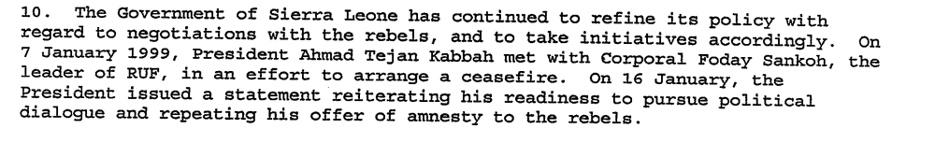
Operation No Living Thing largely directed by RUF soldiers on January 6, 1999
According to Lansana Gberie “civilians were gunned down within their houses, rounded up and massacred on the streets, thrown from the upper floors of buildings, used as human shields, and burnt alive in cars and houses. They had their limbs hacked off with machetes, eyes gouged out with knives, hands smashed with hammers, and bodies burned with boiling water. Women and girls were systematically sexually abused, and children and young people abducted by the hundreds. (2005)

By mid year (1999) the government and the RUF has signed two negotiated settlements. (not direct- Kabbah offered Sankoh to rescind his death sentence if Sankoh would commit the RUF to a peaceful end to the civil war. Sankoh accepted. Peace negotiations commenced in Togo…produced the May 1999 cease-fire and the July 1999 Lome Agreement.

Assessment

Medium-term compliance
No or marginal compliance (1) | x Medium low compliance (2) | Medium high compliance (3) | Full or almost full compliance (4)

Considerations underlying the assessment

The parties showed some important signs of working together on national reconciliation. Despite these positive efforts, this was still two of the most brutal years in the country’s history and the RUF and AFRC were invoking violence.

Depth of demand

Assessment

Level of depth of demand
Low depth of demand (1) | x Medium depth of demand (2) | High depth of demand (3)

Considerations underlying the assessment
Promoting national reconciliation is a medium depth demand primarily because of the verb ‘promoting.’ The parties could promote reconciliation- at least at a basic level- without completely altering their own behaviors.

Level of confidence about coding decisions

Level of confidence about coding decision
Extremely high | x High | Moderate

Comments to IPI (if any)

Civil war in Sierra Leone

UNSC Resolution: | 1181
Date of adoption: | 13 July 1998
Operative paragraph: | 12
Demand number: | 1

Megan MacKenzie

Wording of demand

strictly respect the status of UNOMSIL personnel, as well as organizations and agencies delivering humanitarian assistance throughout Sierra Leone, and respect human rights and abide by applicable rules of international humanitarian law

List of addressees of the demand

Government of Sierra Leone, Armed Forces Revolutionary Council, Civil Defence Forces , Revolutionary United Front

Short-term compliance

Description of the addressee(s)’ conduct

The security situation prevented the mission [UN mission] from deploying fully, however; indeed most of the force was withdrawn to Guinea under the Freetown siege.

Assessment

Short-term compliance
x No or marginal compliance (1) | Medium low compliance (2) | Medium high compliance (3) | Full or almost full compliance (4)

Considerations underlying the assessment

This research indicates an increase in the human rights abuses. In addition, the insecurity created by the parties hindered the UN mission. I have not included research specifying the activities of the Civil Defence Forces; however it is clear that overall, the demand was not complied with.

Medium-term compliance

Description of the addressee(s)’ conduct

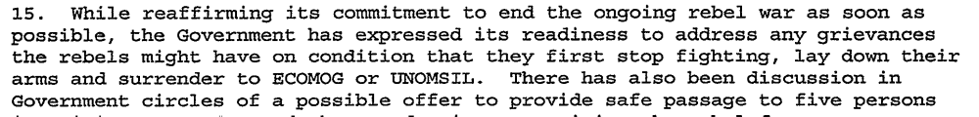
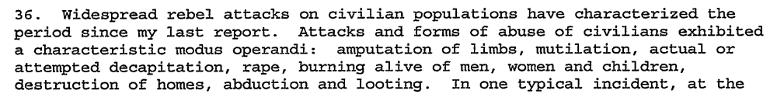

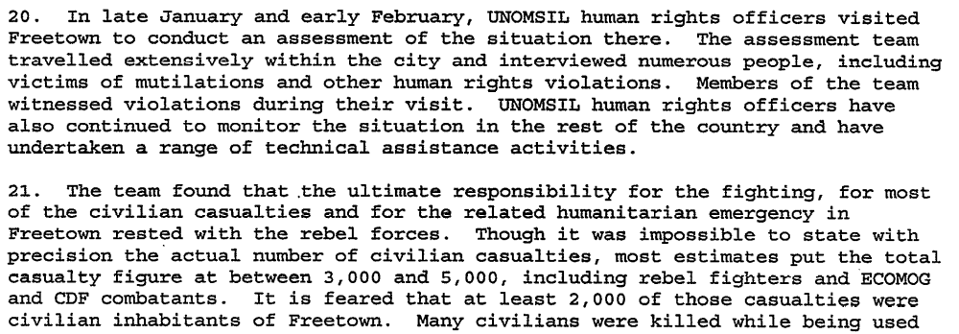
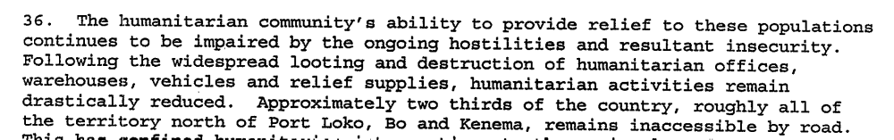
In May 2000 RUF rebels took over 400 UN peacekeepers hostage.

Assessment

Medium-term compliance
x No or marginal compliance (1) | Medium low compliance (2) | Medium high compliance (3) | Full or almost full compliance (4)

Considerations underlying the assessment
There is research indicating that human rights abuses peaked during this time, there were multiple and severe violations of human rights law, and the UN mission had to be suspended due to the severe security situation in January.

Depth of demand

Assessment

Level of depth of demand
Low depth of demand (1) | Medium depth of demand (2) | x High depth of demand (3)

Considerations underlying the assessment
This demand is complex and has several important aspects to it that would require the parties to pay attention to international laws and to change their behavior. It asked them to respect the UN mission and humanitarian organization, as well as human rights and international law.

Level of confidence about coding decisions

Level of confidence about coding decision
x Extremely high | High | Moderate

Comments to IPI (if any)

United Nations Secretary General. First Progress Report of the Secretary General on UNOMSIL. 12 August 1998.
United Nations Secretary General. Second Progress Report of the Secretary General on UNOMSIL with plans for later phases of deployment. 16 October 1998.
Gberie, Lansana. A Dirty War in West Africa: The RUF and the Destruction of Sierra Leone. Bloomington and Indianapolis: Indiana University Press, 2005.
United Nations Secretary General. Second Progress Report of the Secretary General on UNOMSIL with plans for later phases of deployment. 16 October 1998.
Eric G. Berman and Melissa T. Labonte, “Sierra Leone” in William J. Durch ed. Sierra Leone 21st Century Peace Operations. (Washington: United States Institute of Peace) p156-157.
United Nations Secretary General. First Progress Report of the Secretary General on UNOMSIL. 12 August 1998.
United Nations Secretary General. Special report of the Secretary-General on UNOMSIL, containing updated information and revised observations and recommendations 7 January 1999.
Gberie, Lansana. A Dirty War in West Africa: The RUF and the Destruction of Sierra Leone. Bloomington and Indianapolis: Indiana University Press, 2005.
Eric G. Berman and Melissa T. Labonte, “Sierra Leone” in William J. Durch ed. Sierra Leone 21st Century Peace Operations. (Washington: United States Institute of Peace) p160.
Eric G. Berman and Melissa T. Labonte, “Sierra Leone” in William J. Durch ed. Sierra Leone 21st Century Peace Operations. (Washington: United States Institute of Peace) p154.
United Nations Secretary General. Second Progress Report of the Secretary General on UNOMSIL with plans for later phases of deployment. 16 October 1998.
United Nations Secretary General. Third progress report of the Secretary-General on UNOMSIL, with plans for later phases of deployment 16 December 1998.
United Nations Secretary General. Special report of the Secretary-General on UNOMSIL, containing updated information and revised observations and recommendations 7 January 1999.
United Nations Secretary General. Special report of the Secretary-General on UNOMSIL, containing updated information and revised observations and recommendations 7 January 1999.
Eric G. Berman and Melissa T. Labonte, “Sierra Leone” in William J. Durch ed. Sierra Leone 21st Century Peace Operations. (Washington: United States Institute of Peace) p141.

